**Validity Test**

1. Service (X1)

|  |  |  |  |  |  |  |  |  |  |
| --- | --- | --- | --- | --- | --- | --- | --- | --- | --- |
| **Correlations** | | | | | | | | | |
|  | | X1.1 | X1.2 | X1.3 | X1.4 | X1.5 | X1.6 | X1.7 | X1 |
| X1.1 | Pearson Correlation | 1 | .419** | .288** | .216* | .248* | .197* | .151 | .587** |
| Sig. (2-tailed) |  | .000 | .004 | .030 | .012 | .048 | .133 | .000 |
| N | 101 | 101 | 101 | 101 | 101 | 101 | 101 | 101 |
| X1.2 | Pearson Correlation | .419** | 1 | .319** | .328** | .257** | .264** | .201* | .679** |
| Sig. (2-tailed) | .000 |  | .001 | .001 | .010 | .008 | .044 | .000 |
| N | 101 | 101 | 101 | 101 | 101 | 101 | 101 | 101 |
| X1.3 | Pearson Correlation | .288** | .319** | 1 | .372** | .055 | .238* | .039 | .534** |
| Sig. (2-tailed) | .004 | .001 |  | .000 | .582 | .017 | .699 | .000 |
| N | 101 | 101 | 101 | 101 | 101 | 101 | 101 | 101 |
| X1.4 | Pearson Correlation | .216* | .328** | .372** | 1 | .314** | .153 | .203* | .626** |
| Sig. (2-tailed) | .030 | .001 | .000 |  | .001 | .127 | .042 | .000 |
| N | 101 | 101 | 101 | 101 | 101 | 101 | 101 | 101 |
| X1.5 | Pearson Correlation | .248* | .257** | .055 | .314** | 1 | .097 | .240* | .562** |
| Sig. (2-tailed) | .012 | .010 | .582 | .001 |  | .337 | .015 | .000 |
| N | 101 | 101 | 101 | 101 | 101 | 101 | 101 | 101 |
| X1.6 | Pearson Correlation | .197* | .264** | .238* | .153 | .097 | 1 | .202* | .533** |
| Sig. (2-tailed) | .048 | .008 | .017 | .127 | .337 |  | .043 | .000 |
| N | 101 | 101 | 101 | 101 | 101 | 101 | 101 | 101 |
| X1.7 | Pearson Correlation | .151 | .201* | .039 | .203* | .240* | .202* | 1 | .543** |
| Sig. (2-tailed) | .133 | .044 | .699 | .042 | .015 | .043 |  | .000 |
| N | 101 | 101 | 101 | 101 | 101 | 101 | 101 | 101 |
| X1 | Pearson Correlation | .587** | .679** | .534** | .626** | .562** | .533** | .543** | 1 |
| Sig. (2-tailed) | .000 | .000 | .000 | .000 | .000 | .000 | .000 |  |
| N | 101 | 101 | 101 | 101 | 101 | 101 | 101 | 101 |
| **. Correlation is significant at the 0.01 level (2-tailed). | | | | | | | | | |
| *. Correlation is significant at the 0.05 level (2-tailed). | | | | | | | | | |

1. Attractiveness (X2)

|  |  |  |  |  |  |  |
| --- | --- | --- | --- | --- | --- | --- |
| **Correlations** | | | | | | |
|  | | X3.1 | X3.2 | X3.3 | X3.4 | X3 |
| X3.1 | Pearson Correlation | 1 | .618** | .346** | .480** | .800** |
| Sig. (2-tailed) |  | .000 | .000 | .000 | .000 |
| N | 101 | 101 | 101 | 101 | 101 |
| X3.2 | Pearson Correlation | .618** | 1 | .515** | .494** | .872** |
| Sig. (2-tailed) | .000 |  | .000 | .000 | .000 |
| N | 101 | 101 | 101 | 101 | 101 |
| X3.3 | Pearson Correlation | .346** | .515** | 1 | .456** | .701** |
| Sig. (2-tailed) | .000 | .000 |  | .000 | .000 |
| N | 101 | 101 | 101 | 101 | 101 |
| X3.4 | Pearson Correlation | .480** | .494** | .456** | 1 | .751** |
| Sig. (2-tailed) | .000 | .000 | .000 |  | .000 |
| N | 101 | 101 | 101 | 101 | 101 |
| X3 | Pearson Correlation | .800** | .872** | .701** | .751** | 1 |
| Sig. (2-tailed) | .000 | .000 | .000 | .000 |  |
| N | 101 | 101 | 101 | 101 | 101 |
| **. Correlation is significant at the 0.01 level (2-tailed). | | | | | | |

1. Facilities (X3)

|  |  |  |  |  |  |  |
| --- | --- | --- | --- | --- | --- | --- |
| **Correlations** | | | | | | |
|  | | X3.1 | X3.2 | X3.3 | X3.4 | X3 |
| X3.1 | Pearson Correlation | 1 | .618** | .346** | .480** | .800** |
| Sig. (2-tailed) |  | .000 | .000 | .000 | .000 |
| N | 101 | 101 | 101 | 101 | 101 |
| X3.2 | Pearson Correlation | .618** | 1 | .515** | .494** | .872** |
| Sig. (2-tailed) | .000 |  | .000 | .000 | .000 |
| N | 101 | 101 | 101 | 101 | 101 |
| X3.3 | Pearson Correlation | .346** | .515** | 1 | .456** | .701** |
| Sig. (2-tailed) | .000 | .000 |  | .000 | .000 |
| N | 101 | 101 | 101 | 101 | 101 |
| X3.4 | Pearson Correlation | .480** | .494** | .456** | 1 | .751** |
| Sig. (2-tailed) | .000 | .000 | .000 |  | .000 |
| N | 101 | 101 | 101 | 101 | 101 |
| X3 | Pearson Correlation | .800** | .872** | .701** | .751** | 1 |
| Sig. (2-tailed) | .000 | .000 | .000 | .000 |  |
| N | 101 | 101 | 101 | 101 | 101 |
| **. Correlation is significant at the 0.01 level (2-tailed). | | | | | | |

1. Consumer Satisfaction (Y)

|  |  |  |  |  |  |
| --- | --- | --- | --- | --- | --- |
| **Correlations** | | | | | |
|  | | Y1.1 | Y2.2 | Y3.3 | Y |
| Y1.1 | Pearson Correlation | 1 | .595** | .533** | .805** |
| Sig. (2-tailed) |  | .000 | .000 | .000 |
| N | 101 | 101 | 101 | 101 |
| Y2.2 | Pearson Correlation | .595** | 1 | .501** | .825** |
| Sig. (2-tailed) | .000 |  | .000 | .000 |
| N | 101 | 101 | 101 | 101 |
| Y3.3 | Pearson Correlation | .533** | .501** | 1 | .860** |
| Sig. (2-tailed) | .000 | .000 |  | .000 |
| N | 101 | 101 | 101 | 101 |
| Y | Pearson Correlation | .805** | .825** | .860** | 1 |
| Sig. (2-tailed) | .000 | .000 | .000 |  |
| N | 101 | 101 | 101 | 101 |
| **. Correlation is significant at the 0.01 level (2-tailed). | | | | | |

**Reability Test**

|  |  |
| --- | --- |
| **Reliability Statistics** | |
| Cronbach's Alpha | N of Items |
| .873 | 17 |

**Normality Test**

|  |  |  |  |
| --- | --- | --- | --- |
| **One-Sample Kolmogorov-Smirnov Test** | | | |
|  | | | Unstandardized Residual |
| N | | | 101 |
| Normal Parametersa,b | Mean | | .0000000 |
| Std. Deviation | | .96347496 |
| Most Extreme Differences | Absolute | | .064 |
| Positive | | .064 |
| Negative | | -.045 |
| Test Statistic | | | .064 |
| Asymp. Sig. (2-tailed)c | | | .200d |
| Monte Carlo Sig. (2-tailed)e | Sig. | | .385 |
| 99% Confidence Interval | Lower Bound | .372 |
| Upper Bound | .398 |
| a. Test distribution is Normal. | | | |
| b. Calculated from data. | | | |
| c. Lilliefors Significance Correction. | | | |
| d. This is a lower bound of the true significance. | | | |
| e. Lilliefors' method based on 10000 Monte Carlo samples with starting seed 299883525. | | | |

**Multicollinearity**

|  |  |  |  |  |  |  |  |  |
| --- | --- | --- | --- | --- | --- | --- | --- | --- |
| **Coefficientsa** | | | | | | | | |
| Model | | Unstandardized Coefficients | | Standardized Coefficients | t | Sig. | Collinearity Statistics | |
| B | Std. Error | Beta | Tolerance | VIF |
| 1 | (Constant) | 2.382 | 1.211 |  | 1.967 | .052 |  |  |
| X1 | .204 | .047 | .322 | 4.304 | .000 | .732 | 1.366 |
| X2 | -.125 | .082 | -.141 | -1.525 | .131 | .482 | 2.077 |
| X3 | .367 | .052 | .666 | 7.121 | .000 | .469 | 2.134 |
| a. Dependent Variable: Y | | | | | | | | |

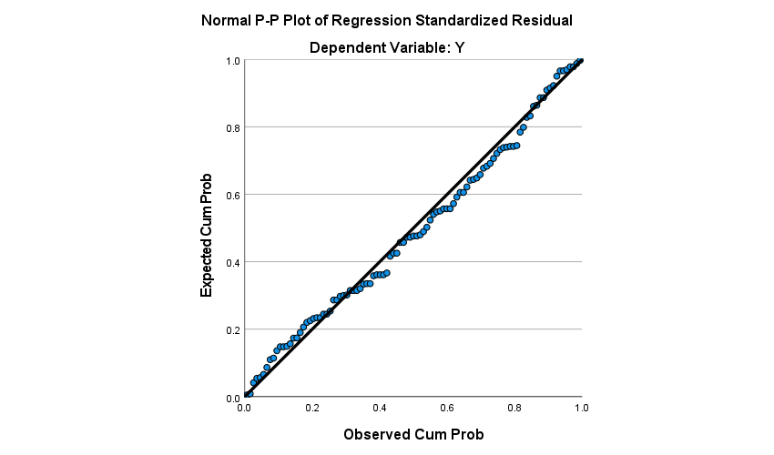**Heteroscedasticity**

**Multiple Linear Regression**

|  |  |  |  |  |  |  |  |  |
| --- | --- | --- | --- | --- | --- | --- | --- | --- |
| **Coefficientsa** | | | | | | | | |
| Model | | Unstandardized Coefficients | | Standardized Coefficients | t | Sig. | Collinearity Statistics | |
| B | Std. Error | Beta | Tolerance | VIF |
| 1 | (Constant) | 2.382 | 1.211 |  | 1.967 | .052 |  |  |
| X1 | .204 | .047 | .322 | 4.304 | .000 | .732 | 1.366 |
| X2 | -.125 | .082 | -.141 | -1.525 | .131 | .482 | 2.077 |
| X3 | .367 | .052 | .666 | 7.121 | .000 | .469 | 2.134 |
| a. Dependent Variable: Y | | | | | | | | |

**F-Test/ Annova**

|  |  |  |  |  |  |  |
| --- | --- | --- | --- | --- | --- | --- |
| **ANOVAa** | | | | | | |
| Model | | Sum of Squares | df | Mean Square | F | Sig. |
| 1 | Regression | 140.498 | 3 | 46.833 | 48.937 | .000b |
| Residual | 92.828 | 97 | .957 |  |  |
| Total | 233.327 | 100 |  |  |  |
| a. Dependent Variable: Y | | | | | | |
| b. Predictors: (Constant), X3, X1, X2 | | | | | | |

**R square**

|  |  |  |  |  |
| --- | --- | --- | --- | --- |
| **Model Summaryb** | | | | |
| Model | R | R Square | Adjusted R Square | Std. Error of the Estimate |
| 1 | .776a | .602 | .590 | .978 |
| a. Predictors: (Constant), X3, X1, X2 | | | | |
| b. Dependent Variable: Y | | | | |